**SMART CAR PARKING SYSTEM**

* NAME : K.SELVARAJ
* REG NO. :953021106063
* COLLEGE CODE:9530
* COLLEGE NAME:ST. MOTHER THERESA ENGINEERING COLLEGE
* NAAN MUDHALVAN:au953021106063

Problem Statement:

The basic objective of a smart parking solution is to identify a vehicle’s presence or absence in a particular parking space with a high degree of accuracy, and to pass on this data into a system for visualization and analysis – to be available for parking asset managers and/or enforcement officers.

Smart parking technologies ensure to reduce the number of cars circling around the streets for finding a parking spot. This ultimately smoothens the traffic flow and minimize the search traffic on streets as much as possible.

**BLOCK DIAGRAM**:

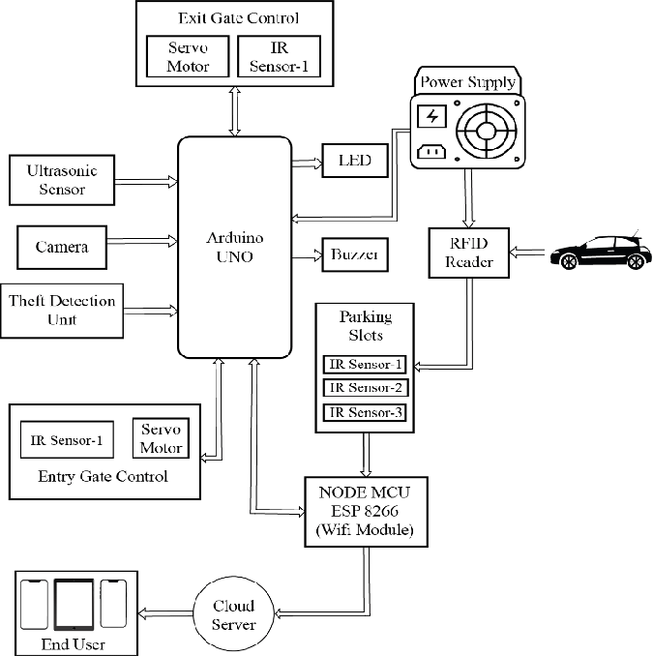

PROGRAM:

#include <Wire.h>

#include <LiquidCrystal_I2C.h>

LiquidCrystal_I2C lcd(0x3F,16,2); //Change the HEX address

#include <Servo.h>

Servo myservo1;

int IR1 = 2;

int IR2 = 4;

int Slot = 4; //Enter Total number of parking Slots

int flag1 = 0;

int flag2 = 0;

void setup() {

lcd.begin();

lcd.backlight();

pinMode(IR1, INPUT);

pinMode(IR2, INPUT);

myservo1.attach(3);

myservo1.write(100);

lcd.setCursor (0,0);

lcd.print(" ARDUINO ");

lcd.setCursor (0,1);

lcd.print(" PARKING SYSTEM ");

delay (2000);

lcd.clear();

}

void loop(){

if(digitalRead (IR1) == LOW && flag1==0){

if(Slot>0){flag1=1;

if(flag2==0){myservo1.write(0); Slot = Slot-1;}

}else{

lcd.setCursor (0,0);

lcd.print(" SORRY :( ");

lcd.setCursor (0,1);

lcd.print(" Parking Full ");

delay (3000);

lcd.clear();

}

}

if(digitalRead (IR2) == LOW && flag2==0){flag2=1;

if(flag1==0){myservo1.write(0); Slot = Slot+1;}

}

if(flag1==1 && flag2==1){

delay (1000);

myservo1.write(100);

flag1=0, flag2=0;

}

lcd.setCursor (0,0);

lcd.print(" WELCOME! ");

lcd.setCursor (0,1);

lcd.print("Slot Left: ");

lcd.print(Slot);

}